GAME2002 – Multimedia Systems Development

Assignment 1

Assignment 1: Single Player Paddle Game
Not all 2D games have to be scrolling shooters and since you’ll have plenty of experience learning how to create one with SFML this term, for your first assignment you’re going to put together a simple pong-like paddle game layout with only one player. You of course MUST use SFML to get user input, create a game window and render a few sprites to the screen. Include the following criteria:

- The game only has one player depicted as a simple rectangular bar at the side of the screen. Alternately you can have the player at the bottom of the screen.
- Whatever your orientation of choice, the player can only move side to side like pong or any paddle game and should be positioned slightly in front of the side of the screen you are trying to protect.
- For the player’s appearance, just make it a thin rectangular bar and the width is up to you but it shouldn’t be more than 6 times as long as it is wide. It can be a sprite you create in any color you like.
- There’s also going to be a ball that can be a simple round sprite any color you wish.
- You’re also going to have to create two text items, one for the player’s lives that can be around 3-5, and one for the player’s score that starts at 0 and counts up when the ball is rebounded by the player’s paddle.
- Although collision detection will fully be covered in Week 9, we are expecting you to do some collision detection as “will be demoed” in the class.
- You have to get the player to move side to side within the constraints of the window, and the ball will spawn somewhere on the opposite side to the player. Therefore, we would like to see ball move movement as demoed in the class.
- Game statistics are important elements to any game. You are going to render another two text items to display frame update statistics: Frames/Second and Time/Update. These two statistics will get updated for every frame.
- Your code should follow Object Oriented Programming style. Game class and Header, Paddle Class and Header, Ball Class and Header. See the following class diagram for help.
- As we cover in week2, there are two ways to make sure we move objects uniformly (Frame-Independent movement and Fixed Time steps). Frame independent movement is not a perfect solution because delta times vary for every frame. For this assignment, you must use fixed time steps to guarantee you always give the same delta time to the update function.
- Last but not the least, as you know, you have to “demo” your assignment in person in the classroom!

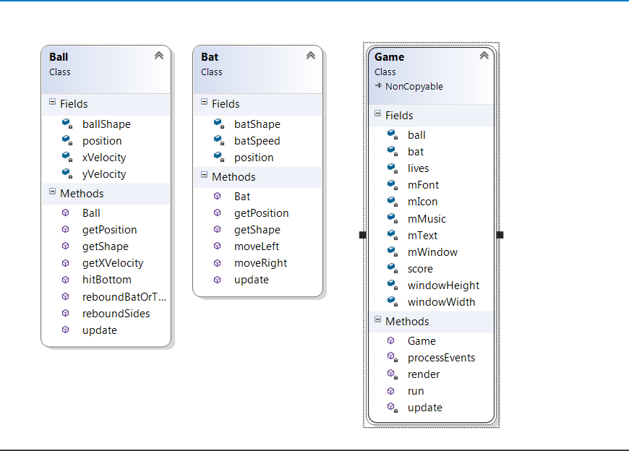

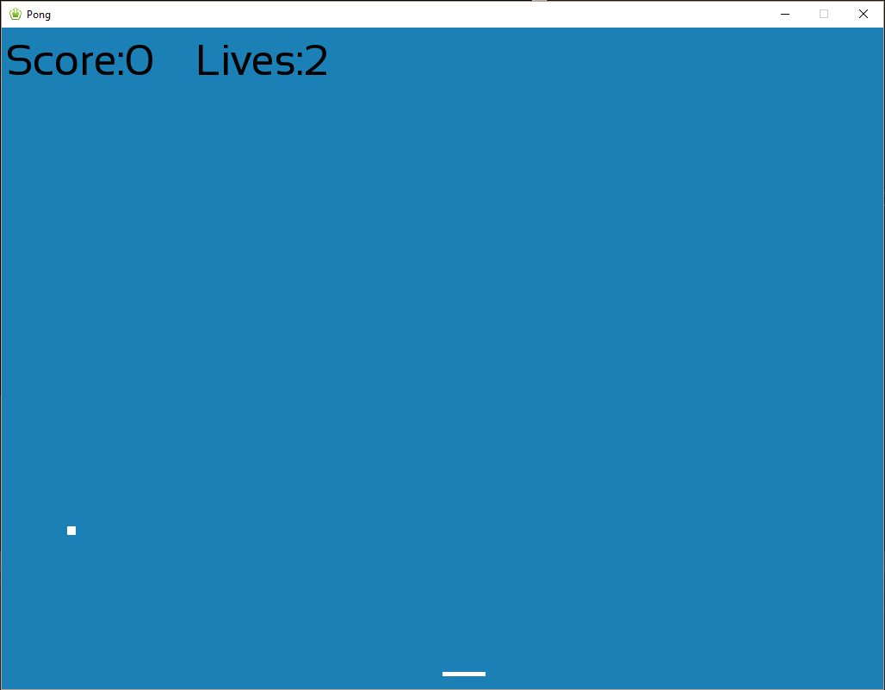

See the mark breakdown for the details of the marking scheme.

Marks: 10% of your grade

Task |  | Mark | Possible  Marks
Window and Sprite Creation |  |  | 4
Sprite and Text Rendering |  |  | 4
Object Oriented Programming |  |  | 4
Player Movement |  |  | 4
Player Bound Creation |  |  | 4
 | TOTAL: |  | 20

